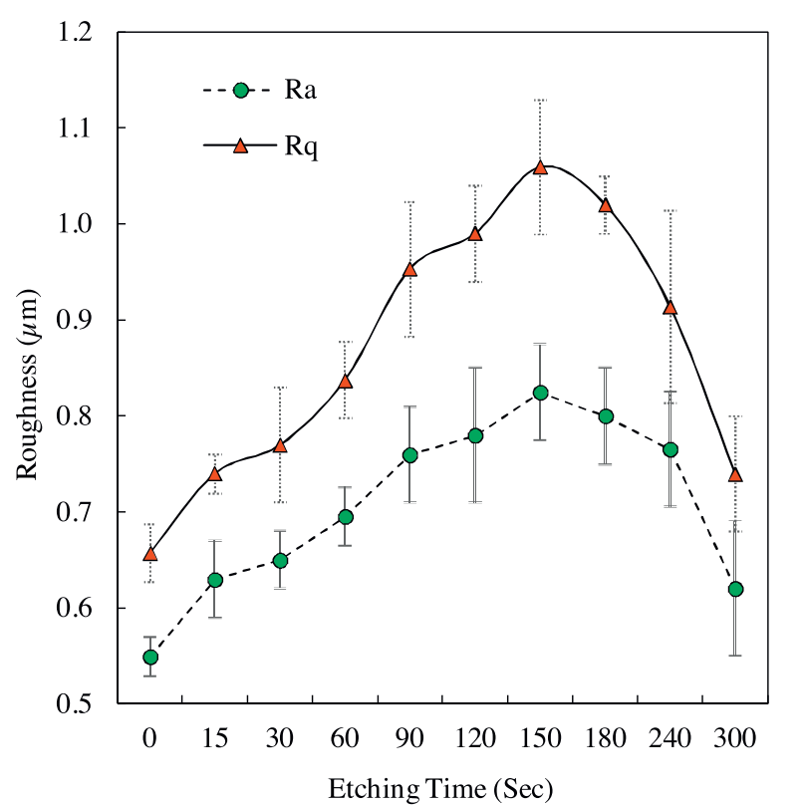
From Effect of roughness and shape factor on flotation characteristics of glass beads
Behzad
They used 10% w/w HF from 40% sigma-Aldrich HF
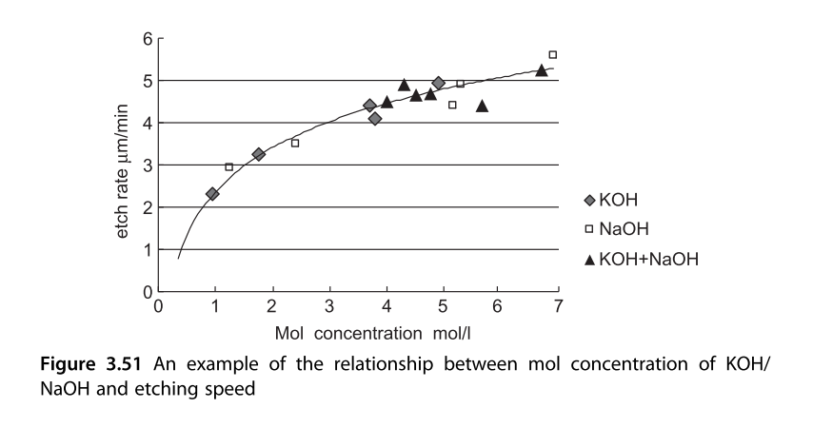
From The Current Situation in Silicon Single Crystals as an Ultra-Precision Technology ? Example

